**Here is a sample html file with a submit button. Now modify the style of the paragraph text through javascript code.**

**Sample HTML file:**

<!DOCTYPE html>  
 <html><head>  
<meta charset=utf-8 />  
<title>JS DOM paragraph style</title>  
 </head>  
 <body>  
 <p id ='text'>JavaScript Exercises - KGMicrocollege</p>  
 <div>  
<button id="jsstyle" onclick="js_style()">Style</button>  
 </div>  
</body>  
 </html>

Design a model based on given output file with ON and OFF Button.

Refer the given Attachment Files.

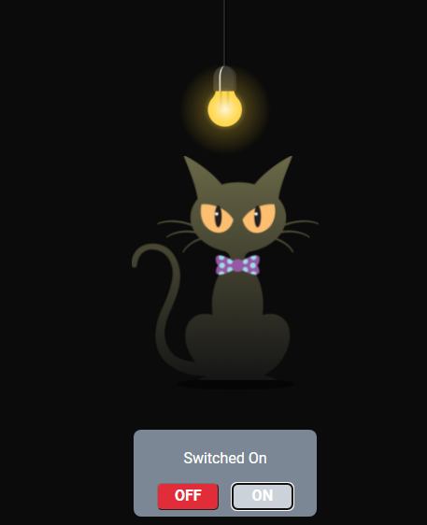

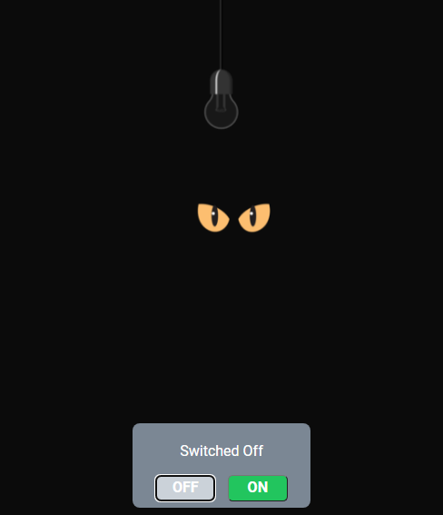

Images

src="https://d1tgh8fmlzexmh.cloudfront.net/ccbp-dynamic-webapps/cat-img.png"

src="https://d1tgh8fmlzexmh.cloudfront.net/ccbp-dynamic-webapps/bulb-go-on-img.png"  
   
src="https://d1tgh8fmlzexmh.cloudfront.net/ccbp-dynamic-webapps/bulb-go-off-img.png"  
   
src=<https://d1tgh8fmlzexmh.cloudfront.net/ccbp-dynamic-webapps/cat-eyes-img.png>

**Traffic Light**

In this assignment, let's build a Traffic Light by applying the concepts we learned till now.

**Refer to the below image.**



**Instructions**:

* The HTML button elements should have the ids stopButton, readyButton, and goButton
* The HTML container elements should have the ids stopLight, readyLight, and goLight

By following the above instructions, achieve the given functionality.

* When stopButton is clicked, the background color of the stopLight container and the stopButton element should change to red. The other HTML elements should have their default background colors as shown in the image.
* When readyButton is clicked, the background color of the

readyLight container and the readyButton element should change to yellow. The other HTML elements should have their default background colors as shown in the image.

* When goButton is clicked, the background color of the goLight container and the goButton element should change to green. The other HTML elements should have their default background colors as shown in the image.